SQL Assessment - Abhiram Basa

**Questions :**

1. Querying Data by Using Joins and Subqueries.
2. Manipulate data by using sql commands using group by and having clause.
3. **Joins:**

Joins are used to get data two or more tables. Joins are classified into following

* Inner Join.
* Left outer join.
* Right outer join.
* Full outer join.

In order to use joins both tables should have matching columns.

**Inner join :**

It will give you the matching values from the tables.

Syntax:

Select * from

Table 1

Inner join

Table 2

On table1.matching_column = table2.matching_column.

Below is my hands on assessment :

Here is my table

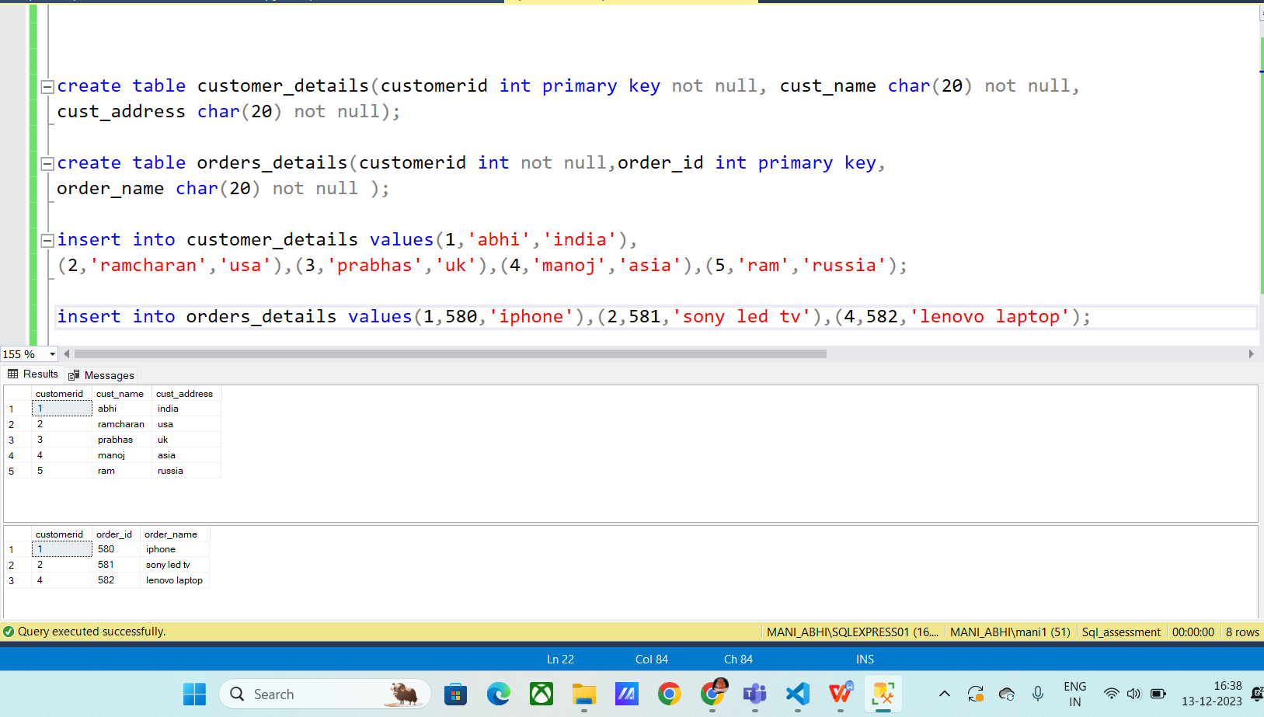

**Inner join :**

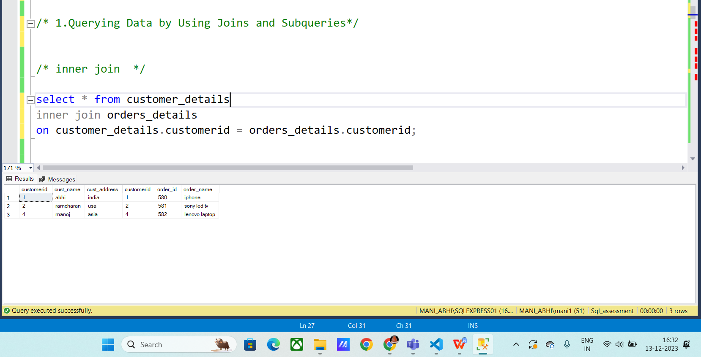

**Left outer join :**

It will give all the values from table 1 and matching values from table 2.

**Syntax:**

Select * from table1

Left outer join

Table 2

On table1.matching_column = table2.matching_column;

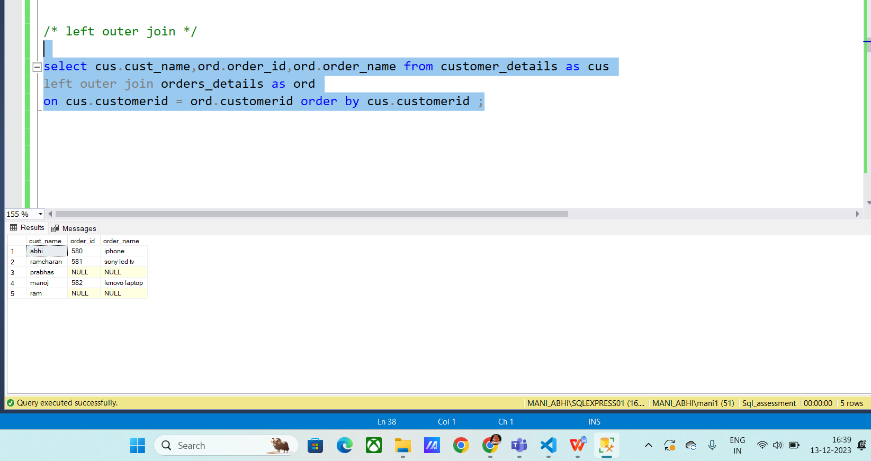

**Right outer join** :

It will give you all value from table 2 and matching results from table 1.

Syntax:

Select * from table 1

Right outer join

Table2

On table1.matching_column = table2.matching_column.

Output:

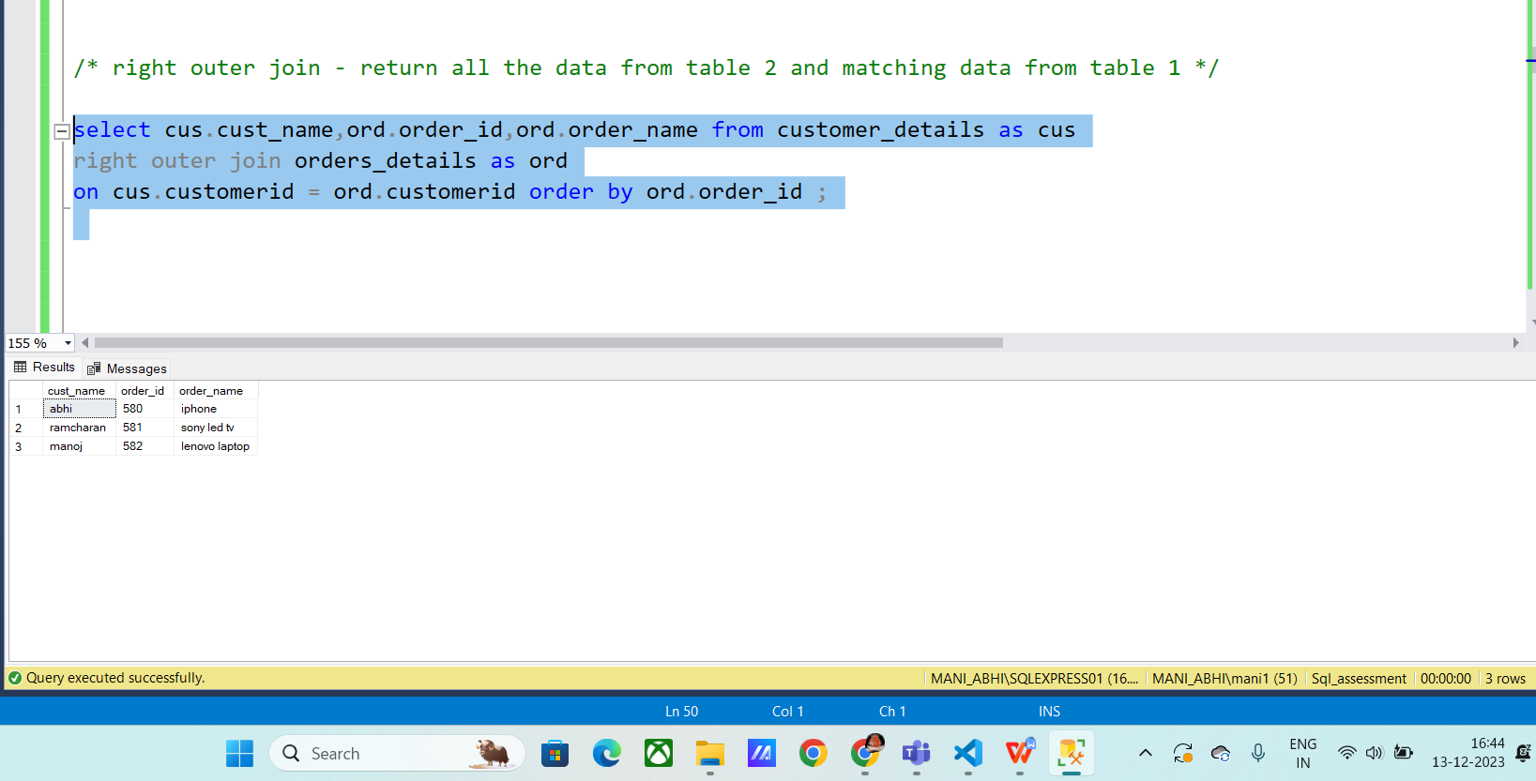

**Full outer join :**

Syntax:

Select * from table1

Full outer join

Table2

On table1.matching_column = table2.matching_column;

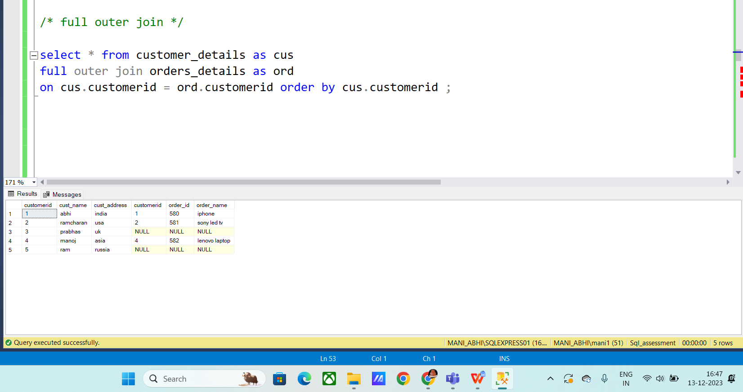

**Sub Queries :**

Sub queries are the nested queries used in retrieving the data.

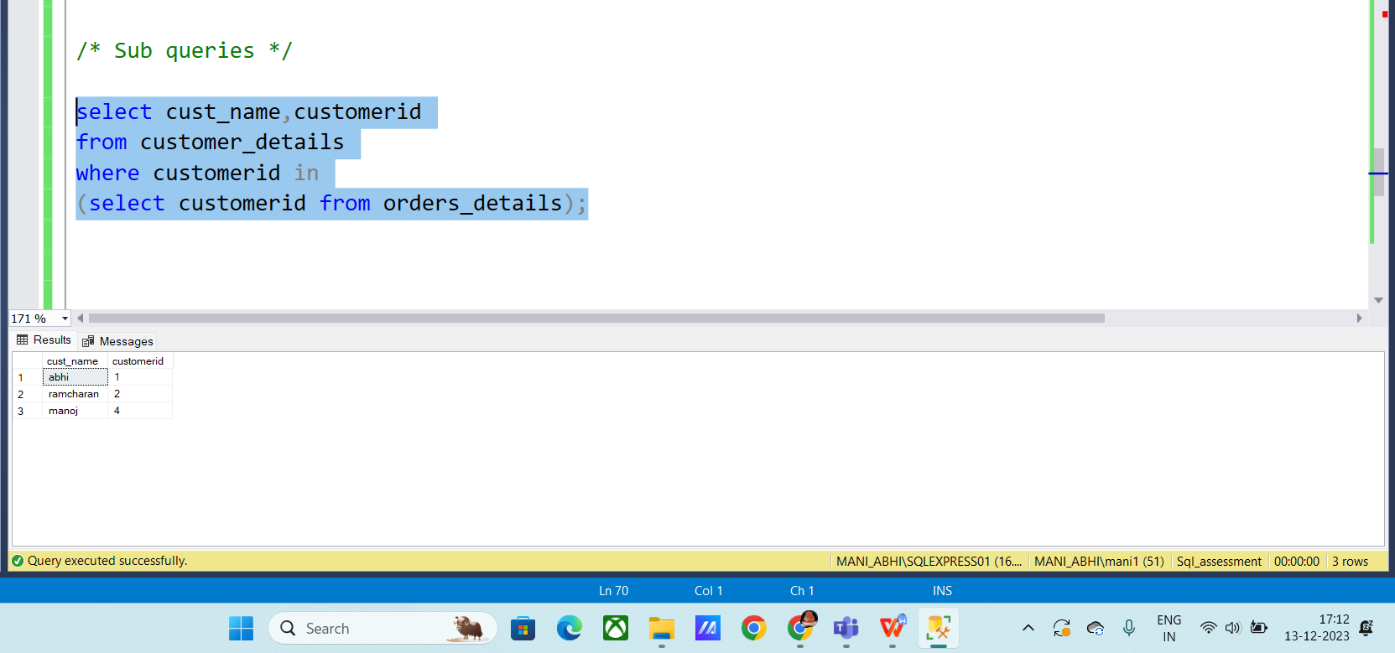

1. Manipulate data by using sql commands using group by and having clause.

**DML Commands** :

Dml is known as Data manipulation language commands and include the following.

Commands :

* Insert
* Delete
* Update

**Insert:**

This command is used to insert data into the table.

Syntax:

Insert into table_name (‘column1’, ‘column2’)

Values (‘value1’, ‘value2’);

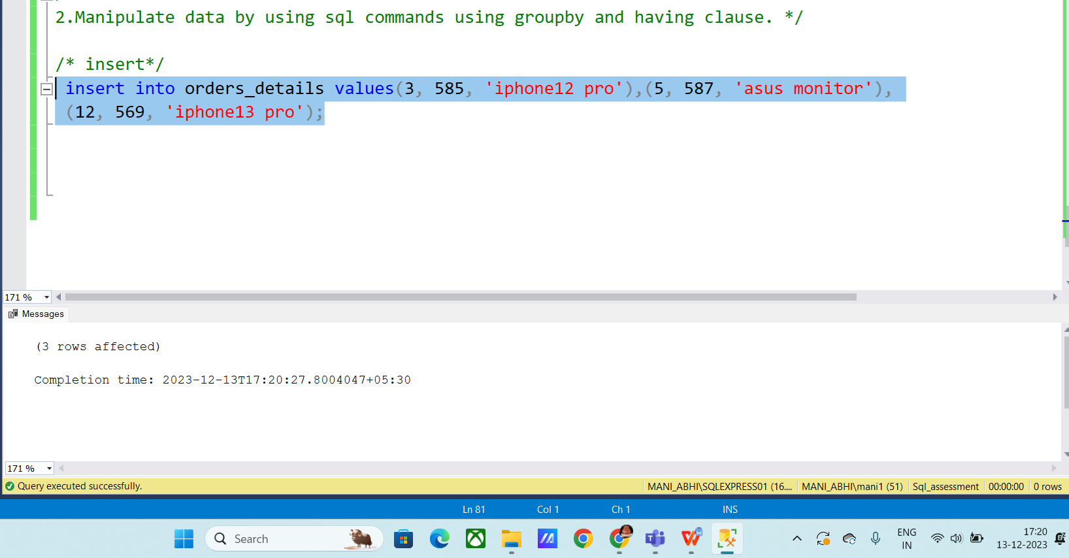

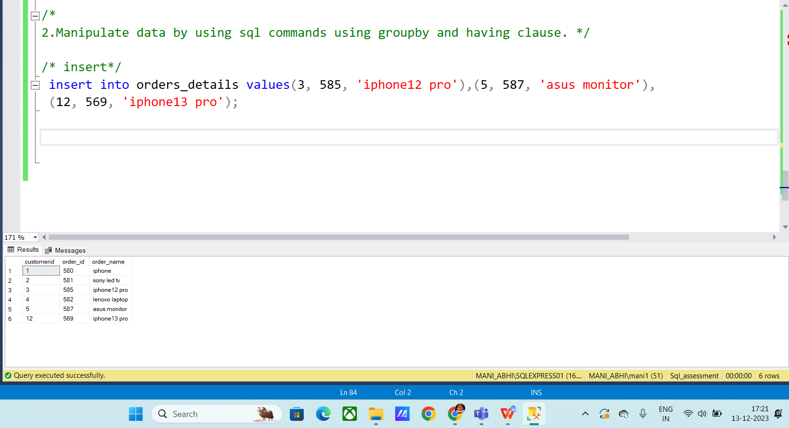

**Delete :**

This command is used to delete data using where condition. It is very helpful in deleting particular data from the table.

Syntax:

Delete from table_name

Where condition ;

Output:

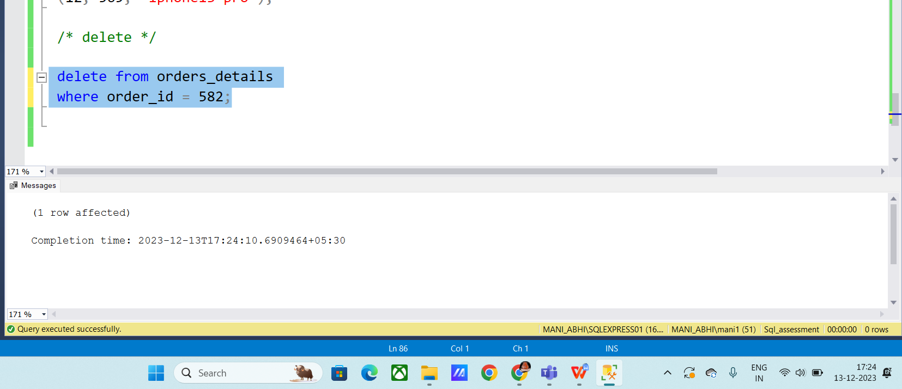

Update :

Syntax:

Update table_name

Set variable where column_name

Output :

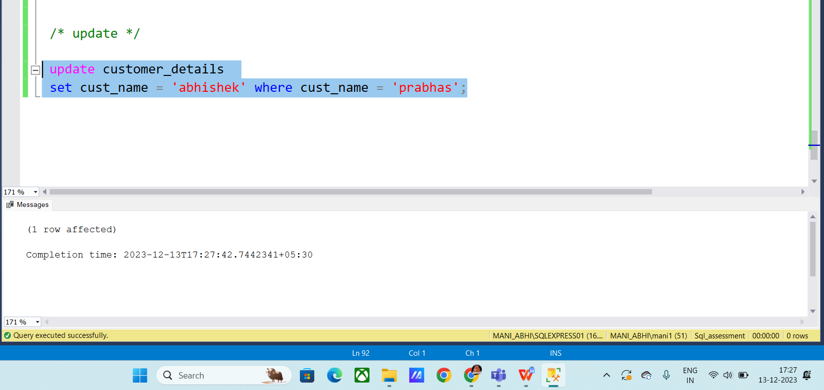

**Group by and Having :**

